EXP 8
Consider a Online Exam Registration Portal. Develop a JavaScript program that will validate the controls in the forms you have created for the application. State the assumptions you make (business logic you are taking into consideration). Note: Your application must access a database using Servlet/JSP.

AIM
To develop an Online Exam Registration Portal that validates user inputs using JavaScript on the client side and accesses a database using Servlet/JSP for storing and processing registration details.
ALGORITHM
- Start the application.
- Display the registration form to the user.
- Accept user inputs such as name, email, password, phone number, and exam details.
- Perform client-side validation using JavaScript:
  - Check for empty fields.
  - Validate email format.
  - Validate password strength.
  - Validate phone number length and format.
- If validation fails:
  - Display appropriate error messages.
  - Prevent form submission.
- If validation is successful:
  - Submit the form to the server (Servlet/JSP).
- On the server side:
  - Receive the form data.
  - Perform server-side validation.
  - Connect to the database.
- Store user details in the database.
- Generate confirmation message for successful registration.
- Stop the application.

STEPS
- Design the registration form with fields like name, email, password, phone number, exam selection, and date.
- Implement JavaScript validation for all form controls.
- Ensure proper error messages are displayed for invalid inputs.
- Configure Servlet/JSP to handle form submission.
- Establish database connectivity using JDBC.
- Create a database table for storing registration details.
- Insert validated data into the database.
- Retrieve and display confirmation details to the user.
- Handle duplicate registrations and invalid data cases.
- Test the application for different input scenarios.
ASSUMPTIONS (BUSINESS LOGIC)
- Each user must register with a unique email ID.
- Password must meet minimum security requirements (e.g., length, characters).
- Phone number must be exactly 10 digits.
- All fields are mandatory.
- A user can register for only one exam at a time.
- Exam date must be a valid future date.
- Database stores all user and exam details securely.
- Server-side validation is mandatory even after client-side validation.
- Duplicate registrations are not allowed.
- Proper error handling and user feedback are provided.

CODE:
<html>
<head>
<script>
function check()
{
if(document.f1.name.value=="")
{
alert("Enter Name");
return false;
}

if(document.f1.mobile.value.length!=10)
{
alert("Enter 10 digit Mobile Number");
return false;
}

alert("Feedback Submitted");
}
</script>
</head>

<body>

<form name="f1" onsubmit="return check()">

Name:
<input type="text" name="name"><br><br>

Mobile:
<input type="text" name="mobile"><br><br>

<input type="submit" value="Submit">
</form>
</body>
</html>

OUTPUT:
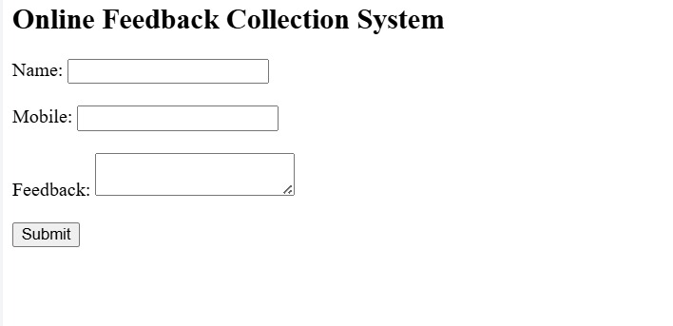

RESULT
The program validates the form successfully using JavaScript.

